Relational Algebra

SQL is a declarative language ⟹ don’t specify the actions HOW to get your data. Do not need to be so explicit. Just specify how the data looks like. We need to know the basic operations (aka relational algebra)

Relational algebra is the assembly language of SQL

Relational algebra: the main objects are relation (aka mathematical definition of a table). Algebra is a set of operations that can act on the objects (like addition, subtraction for math).

NOTE: relational algebra is closed, so if we perform different operations on a table we are always sure that what we will get is still a table (and not something else).

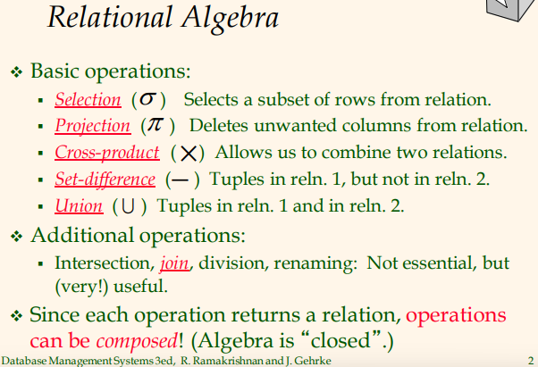

BASIC OPERATIONS
- Selection: you give a table and a condition of the rows: it returns to you another relation (aka table) which contains only the rows that satisfy the condition you want. Select only a subset of the rows. It requires the table and condition
- Projection: delete some columns, it needs a relation and a list of attributes that you want to keep
- Cross-product (cartesian product): takes as input two tables and does the cross product. If you have 5 rows on the first table and 10 in the other table you receive a new table that contains every combination of the two tables (5x10=50)
- Set-difference: give two table as input and return the first table without the elements that appears in the second table
- Union: takes two table as input and get the union (can not be done in all the table)

ADDITIONAL OPERATIONS
These operations can be performed by using different basic operations
- Join:

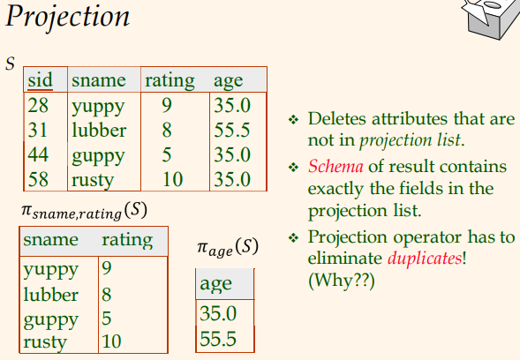
Table with student id, student name, rating and age. We can use projection operations on the table S (students).

Since the output is a new table we need to understand the schema of the new table. It contains exactly what we asked. The risk is that we could have some duplicates in the table (same name and same rating).

⟹ the output can not contains duplicates (to let the algebra be close).

NOTE: SQL will not modify the original data.
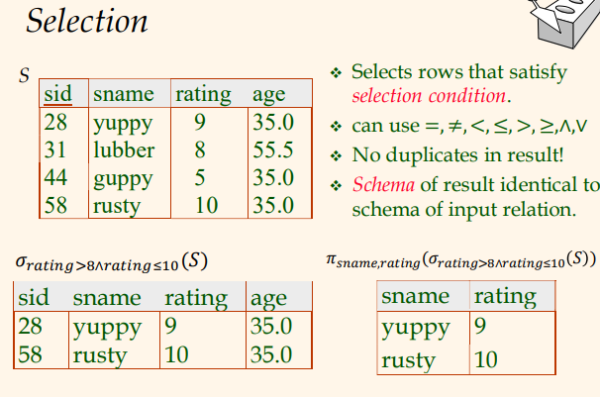

You want students with ratings greater than 8 and smaller than 10. The condition can have any boolean operator you want (and more).

There is no problem with duplicates
⟹ Selection does not remove duplicates

The schema of the output is identical to the input schema (because the columns do not change).

NOTE: we can combine different operations. The best (aka most efficient) order of operations will be found in SQL

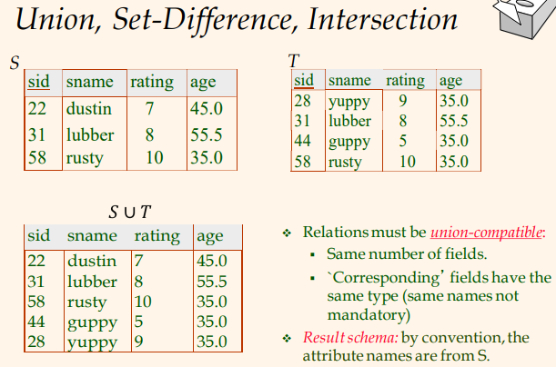
To work it needs two tables and needs to be union-compatible.

If we do the union we get a table that contains both the first and second table (S and T)

⟹ since the algebra must be close do not allow duplicates.

NOTE: not always the union makes sense. We need the two table to have:
- Same number of columns
- Columns must have the same type (float, integer, …)

The name of the columns do not need to be the same. By convention the schema of the result will use the name of the columns of the first table

NOTE: there is only one 58, rusty, 10, 35.0

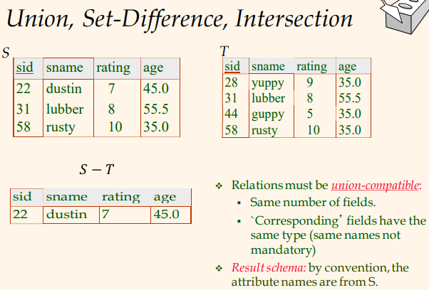
Identical requirements of union. ⟹ union-compatible (but called difference-compatible)

The schema of the result table uses the schema of the first table.
We remove from the left all the tuples that appear on the right.

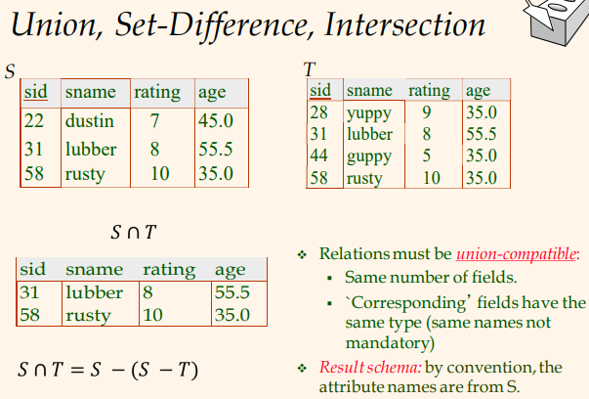
NOTE: intersection is an additional operator
A ∩ B = A - (A - B)

You want to output the tuples that appear in both.

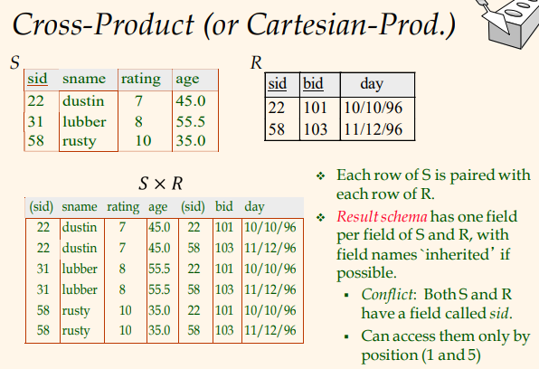

Similar to intersection but is not intersection.

Cross products have two tables of input and output a new relation where the schema contains the columns of the first and the columns of the right. And the output is every combination.

⟹ this can cause some conflicts (like same columns name) but the two columns do not have a name (aka in parentheses like (sid) (needs an operator to choose the columns)) ⟹ better to have columns with name specific on each table

NOTE: is a heavy operator, is very demanding
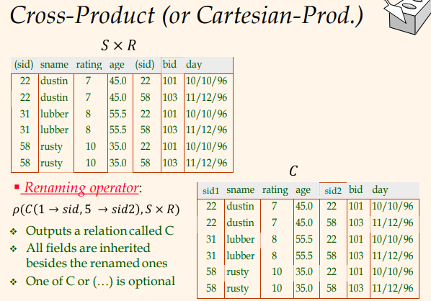
We use the renaming operator ρ (rho) to specify the relation we want to work on and the name we want to give to the result).

column n.1 must be called sid
while column n.2 must be called sid2. Now we can refer to all the columns

The rename operator is use mostly in two situations
- fix the clash
- make table more readable

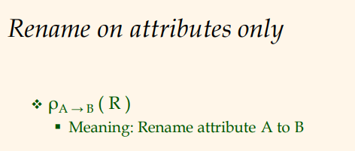
Short form for name. to rename attribute A to attribute B

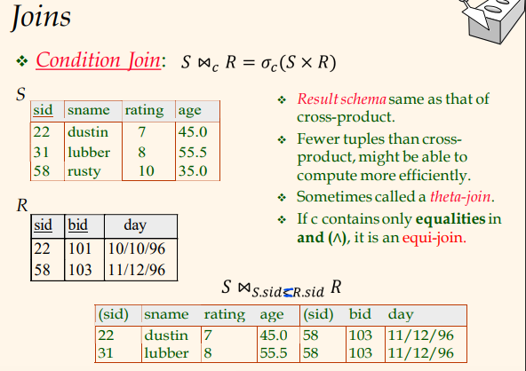
Super useful and used in every query. Is used for cartesian products and selection.

Usually called condition joint or theta-joint.

It operates on two tables and performs a cartesian product of the two tables, then it apply a selection operator (with some condition c).

In the example: the condition is the student id of table S should be the same in the R table.

NOTE: commonly the condition is = (aka equi-joint), so that we keep the rows where the sid is the same, but we need to try every combination

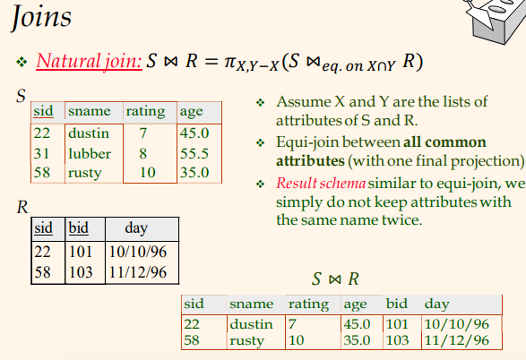

Another common version of condition joint (like equi-joint) is natural join

It is a version of equi-joint that performs the equality over every attribute that have the same name.

After you perform the cross product keep only the rows where the attribute with the same nave have the same values.

Natural joint also avoid clash of attributes names.

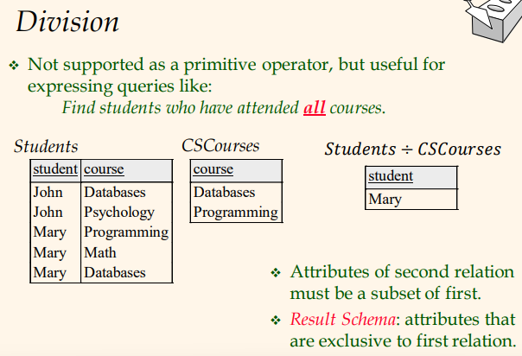
Division do not have any corresponding operator and needs to be manually implemented/imported (it can also be represented by basic operator).

Want to find the students that have attended all the courses.

The input must be two tables where the columns of the second table is a subset of the first table.

